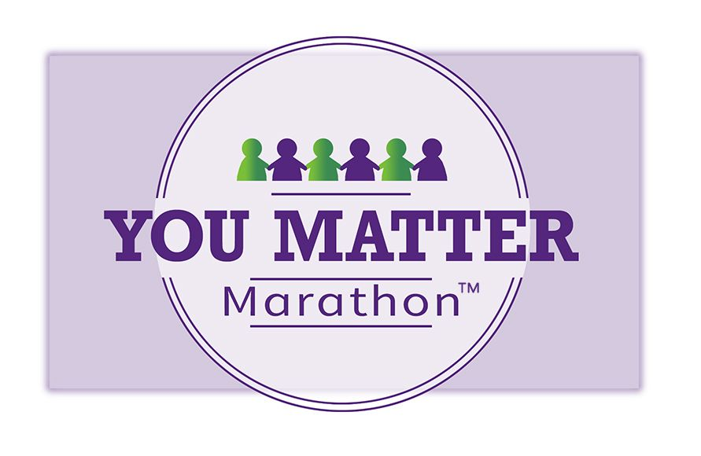
You Matter Marathon Journal

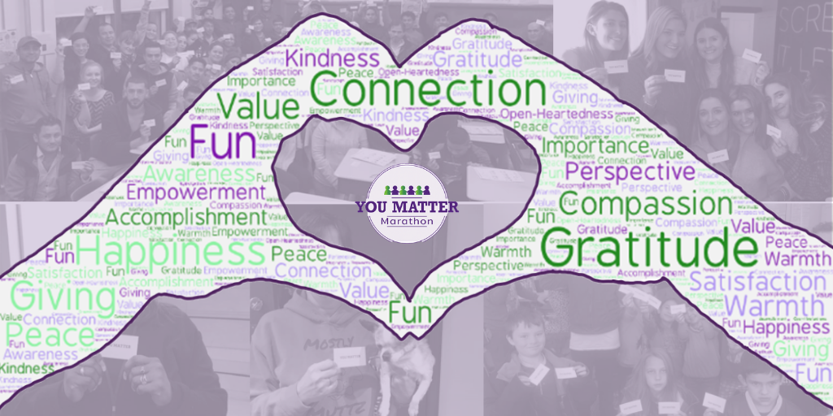
Welcome!

Whether this is your 1st or 7th You Matter Marathon we know you’re in for a month of magic.

We offer this journal as a personal companion to accompany you on your journey and to deepen and honor your experience.

Enjoy the opportunity to reflect on the following questions throughout the You Matter Marathon.
“Having the You Matter cards has caused me to look at people differently. This is making me a much more connected human.”
–Julie
Before the Marathon: Questions on Mattering

- What does it mean to matter? What is your definition of mattering?

- Who in your life makes you feel that you matter? What do they do to make you feel that way?

- Think of a time in your life when you felt like you mattered. What was happening?

- Besides sharing You Matter cards, how else do you show people that they matter?

- What would be different in your life if you knew in your bones that you mattered?

- If you could choose one person in the world to hand a You Matter card to, who would it be?

Before the Marathon: Preparing to Participate

- Why did you sign up for the YMM? What do you hope to gain?

- What are you looking forward to regarding this experience?

- What are you concerned or nervous about, if anything?

- Have you ever received a You Matter card? If so, how did it make you feel?

- How would you feel about yourself if you changed someone’s life by giving them a card with these two words?

- Who will you give your first card to and why?

- Will you give out one card a day or give them out in bunches?

- Where might you place a YM card for someone else to find? Some suggestions from past participants include: in the slot at the ATM, in a food donation bag, beside your tip on a restaurant table, under the windshield wiper of a random car in a parking lot.

- Will you also share digital YM cards? They can be found here, https://youmattermarathon.org/digital-you-matter-cards/.

- Who can you share this experience with? (Hint: A family member or friend, YMM FB group, our founder, Cheryl Rice)

During the Marathon

- What did it feel like to give out your first card? How did the recipient respond?

- As you gave out more cards, did you feel even more engaged in the process?

- Were there any times when it seemed harder to give out a card than others? If so, why?

- What You Matter story and/or photo will you share in the YM Facebook Group or the Share Your Story section of our website?

Use the You Matter Marathon Card Giving Log on the next two pages if you want to keep track of each card you give.

You Matter Marathon Card Giving Log

Date | Who?/How? | How Did the  Person React? | How did You Feel?

After the Marathon

- What was the most memorable card share for you?

- What surprised you about sharing YM cards?

- What impact has participating in the YMM had on you?

- When you reflect on mattering now, what are your feelings about it?

- What will you continue to do to remind other people they matter?

- What will you continue to do to remind yourself that You Matter?

“The You Matter Marathon has become a part of who I am! I always have cards with me and every day I find someone who could benefit from getting a card! I am proud to be a YuMMie!”
–Kellie

Feel free to share your feedback on this journal or any other aspect of the YMM with Cheryl at cherylrice210@gmail.com.

